

**Department of Mechanical and Nuclear Engineering**

**Nuclear Reactor Theory**

**0407308**

**Final Examination Solution**

**Spring 2023-2024**

**Time/Date: 8:30 - 10:30, May 8, 2024**

**Room: W10-002**

**Instructor: Dr. Thanh Mai Vu**

|  |  |
| --- | --- |
| Student Name | Student ID |
|  |  |

**Rules:**

1. Begin by writing your name and student ID.
2. **Closed-book exam, only a calculator is allowed.**
3. Using mobile phone and smart watch during exam is not allowed. Any academic dishonesty will result in *“F”* for your final grade.
4. Write the answer neatly and clearly. The result should be written with its unit.

**For Instructor:**

|  |  |  |  |  |  |  |  |
| --- | --- | --- | --- | --- | --- | --- | --- |
| **Question** | **1** | **2** | **3** | **4** | **5** | **6** | **Total** |
| **Grade** |  |  |  |  |  |  |  |
| **Out of** | 6 | 6 | 6 | 6 | 15 | 6 | 45 |

**Useful Equations:**

One group NDE:

Material Buckling

The leakage to absorption ratio

For cylindrical geometry:

The average neutron flux in the reactor.

**Problems:**

1. **(Total 6 points)**

a. (2 points) What is reaction rate?

***Solution:***

The reaction rate is the number of interactions taking place in one cubic centimeter per one second.

* b. (4 points) A monoenergetic beam of neutrons, = 4 × 1010 neutrons/cm2-sec, impinges on a target 1 cm2 in area and 0.1 cm thick. There are 0.048 x 1024 atoms per cm3 in the target, and the total cross-section at the energy of the beam is 4.5 b.

Calculate the macroscopic total cross-section and number of neutron interactions per second occur in the target.

***Solution:***

* The macroscopic total cross-section:

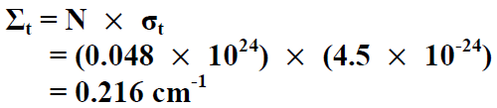

* Number of neutron interactions per second occur in the target:

8.64*

1. **(Total 6 points)**

a. (3 points) Write the 4-factor formula and define each factor

***Solution:***

Four factor formula

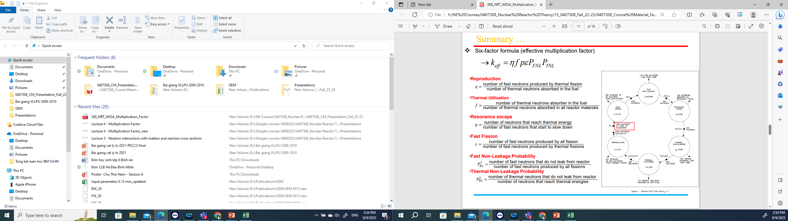

b. (3 points) In a thermal nuclear reactor at the beginning of its life for every 1,000 neutrons, 500 neutrons are absorbed in 235U, 225 neutrons are absorbed in 238U, 125 neutrons are absorbed in coolant and cladding, 150 neutrons leak out from the geometrical core boundaries, and ν is 2.43.

Calculate the multiplication factor and the conversion ratio value for this reactor

***Solution:***

Assume that all neutrons absorbed in U235 cause fission reaction, the multiplication factor of the reactor is:

k1 =500*2.43/1000=1.215

The conversion ratio value for this reactor?

==0.45

1. **(Total 6 points)**

a. (3 points) Complete the following neutron transport equation:

Leakage

Source

In-scattering

***Solution:***

b. (3 points) Three isotropic neutron sources, each emitting *S* neutrons/sec, are located in an infinite vacuum at the three corners of an equilateral triangle of side *a*.

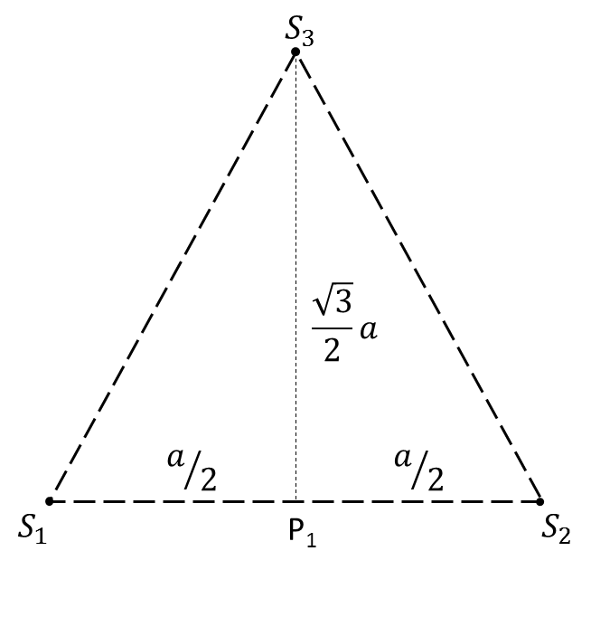Find the flux at P1 - the midpoint of one side.

Flux of point source in infinite medium:

***Solution:***

Total flux at position P1:

1. **(Total 6 points)** A plane source of strength neutrons/sec is placed in an infinite medium. The material has an absorption cross section and a diffusion coefficient . Neglect the extrapolation distance.

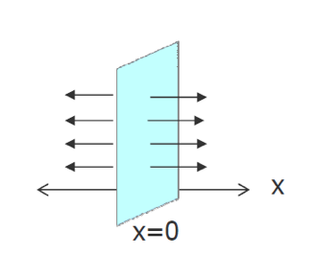

* 1. (3 points) Write down the diffusion equation and its general solution for this problem for

.

***Solution:***

General solution:

* 1. (3 points) Solve the general equation for by applying 2 following conditions:

***Solution:***

Applying physical condition:

Applying source condition:

Determine : From Fick’s law:

Then

**Final solution:**

1. **(Total 15 points)**

For a cylindrical shape reactor with the following information:

* Initial boron concentration = 2200 ppm
* of Boron = 600 b, of Boron = 0 b.
* Mass number of boron = 10.811
* For water, =0.035 /cm, =0.00 /cm, =0.050 /cm
* For fuel, =0.650 /cm, =0.40 /cm, =0.040 /cm, =2.5
* Fuel to Moderator volume ratio= 1/3
* Avogadro number = 6.022x1023 atom/mole
* Power=1000 MWth
* Do not neglect the extrapolation distance.

Answer the following equation using 1-group diffusion theory:

* 1. (2 points) Calculate for a mixture of fuel, water, and boron.
  2. (2 points) Calculate the diffusion coefficient.
  3. (2 points) Find a geometrical buckling that makes the reactor critical.
  4. (3 points) If the diameter of the reactor is 150 cm, calculate the critical height of cylinder.
  5. (2 points) Calculate the leakage to absorption ratio.
  6. (2 points) Calculate the average neutron flux in the reactor.
  7. (2 points) Calculate the maximum neutron flux in the reactor.

1. **(Total 6 points) Diffusion equation for group g is written as follows:**

a. (3 points) Explain the meaning of each term of the equation

b. (2 points) Write down the multigroup diffusion equation for steady-state condition.

c. (1 point) Write down the steady-state multigroup diffusion equation in case the fission source is much more dominant compared to the external source.

***Solution:***

a.

Leakage

Total interaction

Fission source

Scattering in

External source

Rate of change in neutron flux

b. For steady-state condition:

c. Neglecting the external source: